
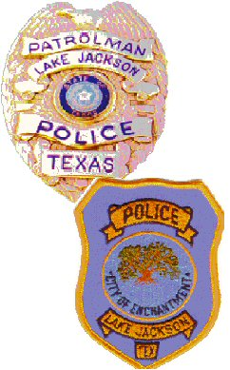

CITY OF LAKE JACKSON

POLICE DEPARTMENT

PRESS RELEASE
05-11-2019 9:20 A.M.

The odors in our area are a result of a ship and barge collision yesterday in the Houston ship channel. The collision resulted in a release of an unknown amount of a gasoline blend product. According to CAER, there are no chemical plant emergencies in the Brazosport area. Air monitoring is being conducted along the shoreline from Sylvan to Kemah. Any actionable levels will be reported to the local County Emergency Operation Centers. A 24/7 air monitoring hotline has been established for the public to report strong odors by calling 281-757-3017.

Bryan R. Sidebottom
Administrative Lieutenant
PIO
Office: 979-415-2705
Email: bsidebottom@lakejacksonpd.net

